**Critical Thinking 1**

Alastair A. Ohde

Colorado State University Global

CSC 320-1

Vanessa Cooper

February 16. 2025

Start

Print

First name

Last name

Street address

City

Zip code

End

**package** CSC320;

**public** **class** Test1 {

**public** **static** **void** main(String[] args) {

System.***out***.println("Drop dead /n" + "something here");

String firstName = "";

String lastName = "";

String address = "";

String city = "";

String zipCode = "";

System.***out***.println("FIRST NAME: " + firstName);

System.***out***.println("LAST NAME: " + lastName);

System.***out***.println("Street Address: " + address);

System.***out***.println("CITY: " + city);

System.***out***.println("Zip Code: " + zipCode);}

}

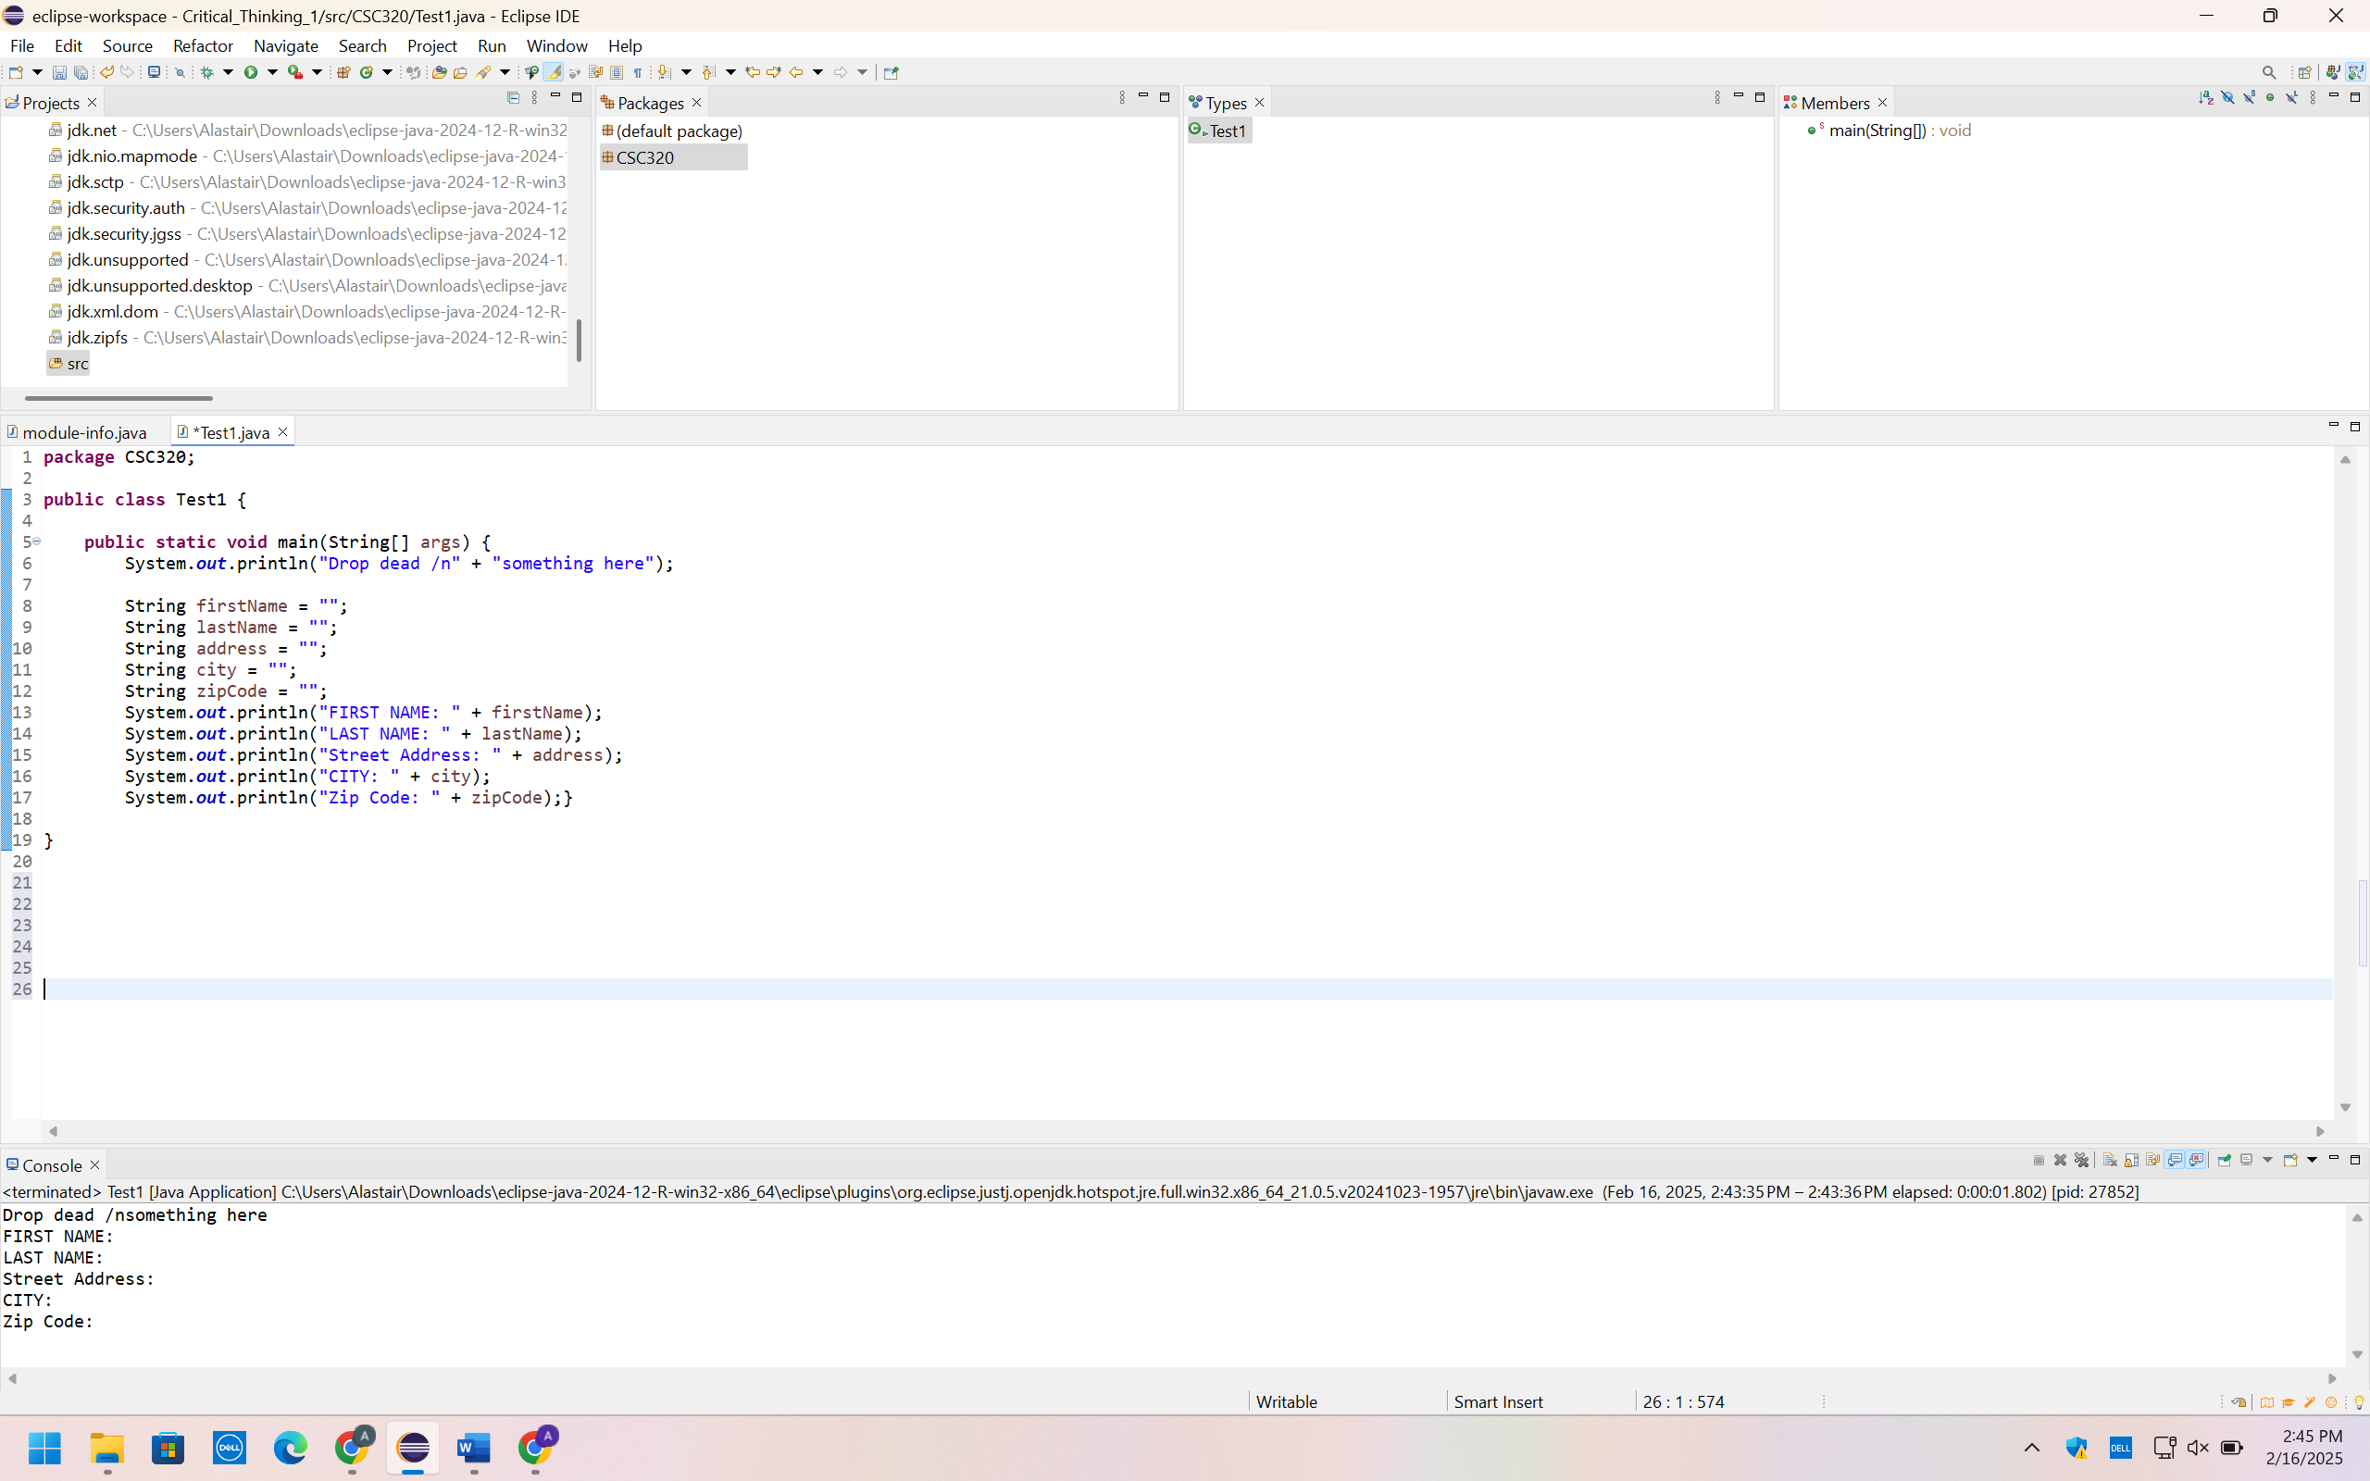

https://github.com/Ebberous/CSC320-1-Critical-Thinking